1. Find out the mail severs of the following domin:

Ibm.com

Wipro.com

Ans:

-->To get the mail sever we have type the command “nslookup ” in the command prompt and then type “set type= mx” and then type given websites. So we get DNS as follows:

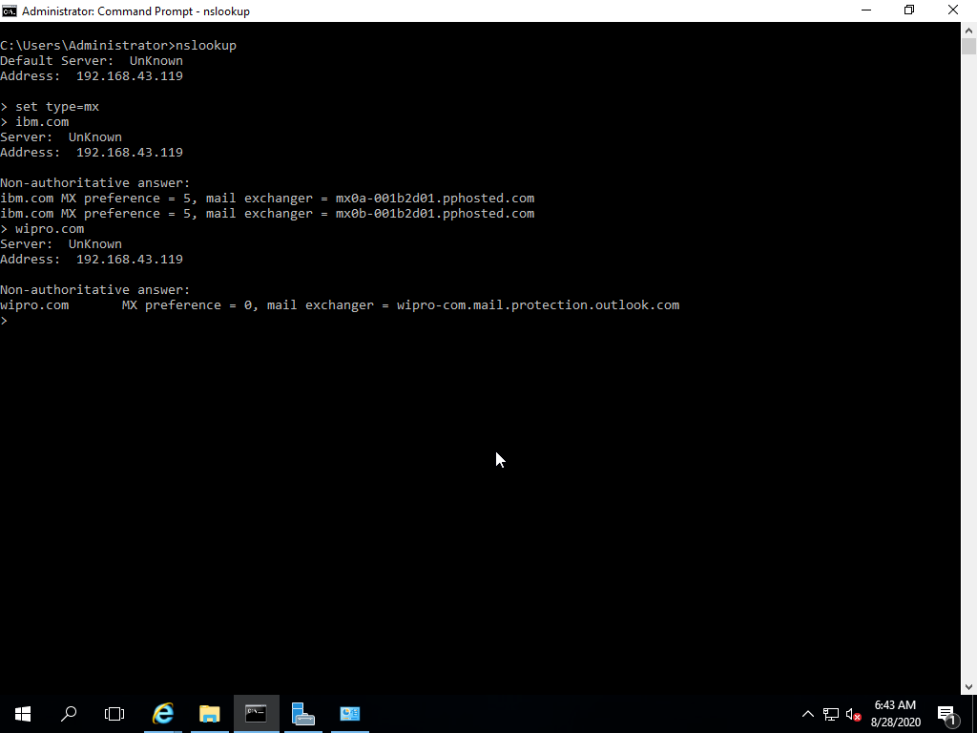

2)Find the locations, where these email severs are hosted.

Ans:

Sir, As you said we can not find the locations by DNS. But we can find the locations using email address by the following link:

<http://www.my-addr.com/email_server_location/e-mail_box_server_location/locate_email_address_for_free.php?ept_email=bWFpbEBpYm0uY29t&x=0&y=0>

**we get following details for given mails:**

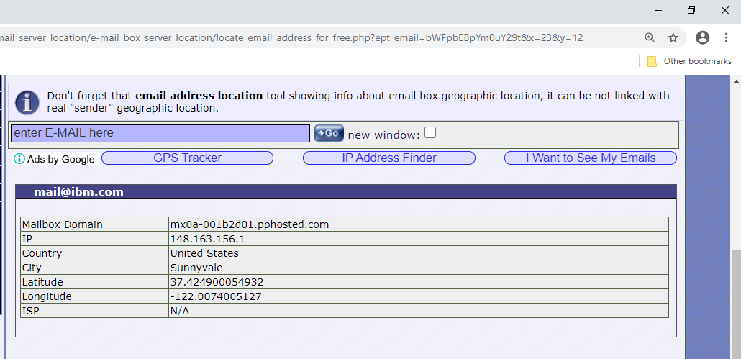

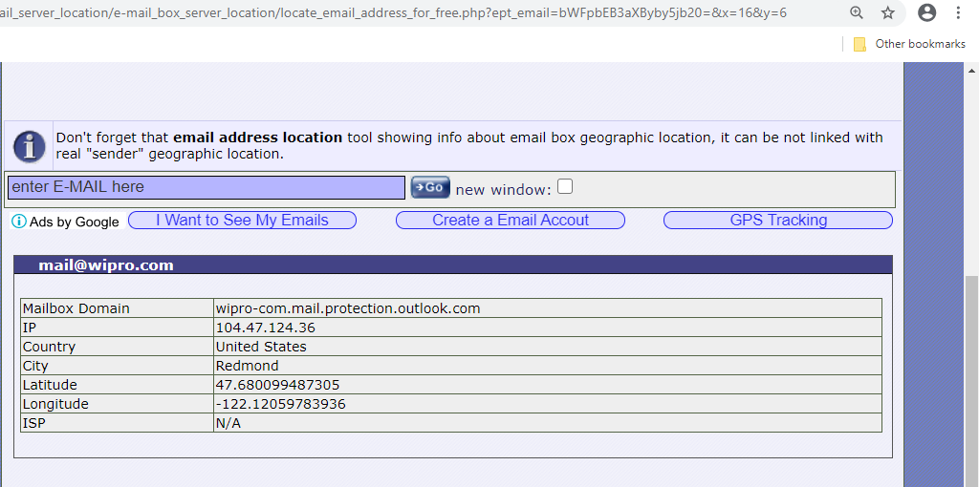

3)Scan and find out port numbers open 203.163.246.23

Ans: open terminal in kalli linux and type the following command:

“ nmap 203.163.246.23 ”

We get tha open port as : 513 as shown in image

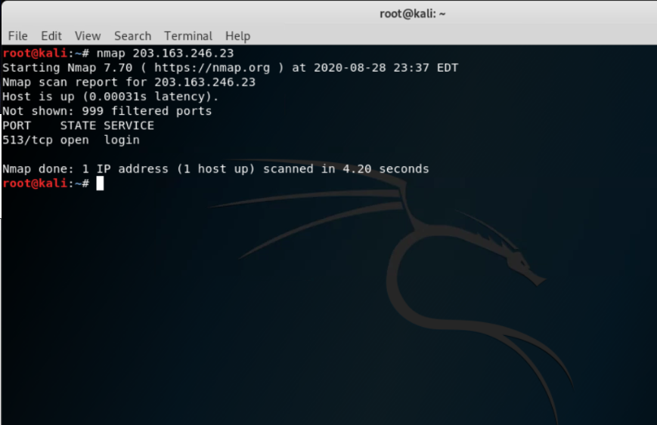

4) Install nessus in a VM and scan your laptop for CVE.

Ans: open Pen Tester in VM and download nessus from chrome or internet explorer . Now using Remote Desktop connect to your laptop/desktop using the ip address and scan the laptop using the nessus application. We get the result as shown in the image below:

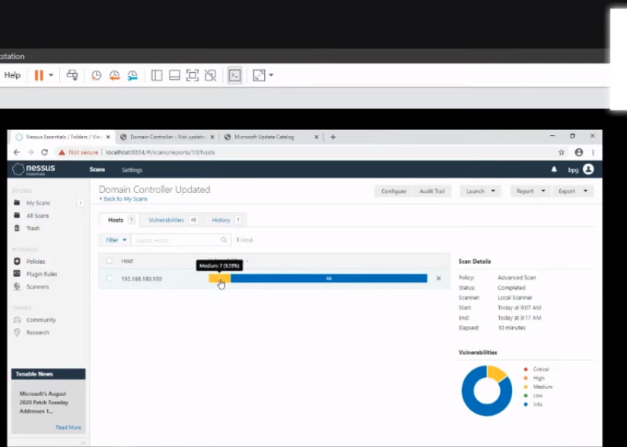

********THANK YOU**********